Road simulation testing equipment
Chassis suspension abnormal sound detection equipment
operation instruction

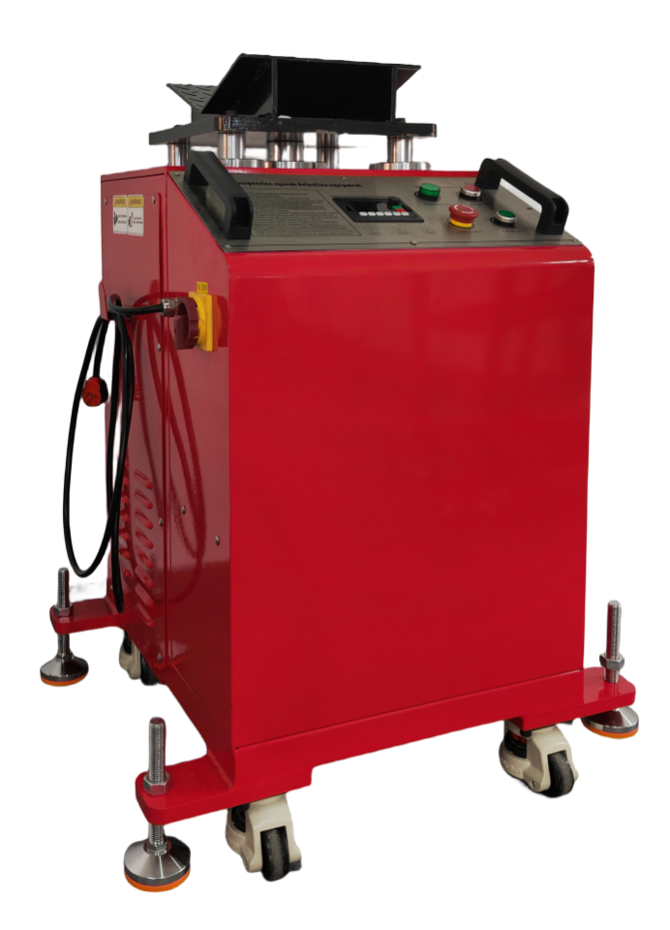

Ⅰ、 precautions
1. Before using the equipment, please read this manual carefully for correct operation.
2. During the process, do not allow children to approach the equipment, and do not put hands or tools into the danger area. When multiple people operate, determine the commander and coordinate the actions closely to avoid accidents.
3. During maintenance, the power supply must be cut off. If the power supply must be switched on for maintenance or maintenance of the circuit, do not contact any conductive part of the equipment, which will cause electric shock.
4. Please use the safe power supply (220V/380/50-60Hz) that meets the requirements of the equipment. Please check the power supply before use. If any damage is found, repair it immediately to ensure the normal operation of the machine.
Ⅱ、why should the car chassis be tested
The automobile chassis is composed of four parts, including the transmission system, the driving system, the conversion system and the braking system. It supports and installs the automobile engine and each component assembly to produce the overall design of the automobile and bear the driving force of the automobile engine.
In daily maintenance, in addition to some parts that need to be replaced regularly, it is necessary to regularly check some parts, such as brake discs, brake linings, brake pipes, steering rod joints, shock absorbers, and some rubber parts (such as tires, ball caps, thigh and calf rubber boots), if these parts fail due to wear or aging, It will cause potential safety risks to the vehicle.
In the maintenance process, we must carry out a detailed inspection of the vehicle parts, it should be noted that if most of the parts of the chassis are damaged, the vehicle will emit abnormal or bumpy noise when driving, the owner hears these abnormal sounds, find the parts and reasons as soon as possible, and then repair, in order to ensure driving safety as much as possible. (Suggestion: need to check every six months or so)
Ⅲ、Project overview
The detection of automobile chassis components belongs to the detection project of each auto repair factory, which can detect and eliminate faults in advance. The diagnosis is more accurate and reliable with the chassis suspension abnormal-shaped detection equipment, which includes the chassis suspension abnormal-shaped detection host and the rear wheel fixed frame.
1. In the test conducted on the double-column platform, different from daily driving, all chassis components are in a fully stretched state, which makes all parts deformed, unable to make accurate detection, and even cause damage to parts. Such a test method cannot reflect the actual state of the car. At the same time, it often causes damage to the chassis.
2. Testing on the four-column platform can not meet the driving state, nor can it fully realize the simulation of actual driving, so it is necessary to let the mechanic do everything possible to find some extremely small faults, chassis suspension shaped testing equipment, which can directly simulate the ground for driving depth detection, accurate grasp of the testing equipment mechanics, with professional feelings can find the initial wear, Without these inspection equipment, we can not perform accurate maintenance on the car; The use of inspection equipment, such as through the strong effect of the equipment on the entire car, the detection of the shock absorber tray and pedal support, and in some cases the engine frame, the shock absorber compression, the smooth application of pressure on the chassis, can then be reliably inspected at any time, especially for those that are usually difficult to detect, such as the large rubber metal parts of the rear axle. Our detection is accurate and reliable, in addition to the multi-link suspension, the production of push and pull motion to simulate the stabilizer rod connecting rod, road simulation testing equipment is to make the detection of car chassis fault safer, simple and rapid, mutual double detection equipment has become the right hand of all auto repair plants, suitable for all models with a total weight of less than 3 tons.
Ⅳ、Equipment overview
The equipment is the use of frequency conversion control device, strong anti-interference ability, low failure rate, chassis suspension special-shaped testing equipment is composed of frame, deceleration linkage mechanism, frequency conversion electric control system, etc., through the linkage of the whole machine, the mechanism up and down reciprocating movement, the overall welded structure makes the fuselage maintain enough rigidity while having better stability.
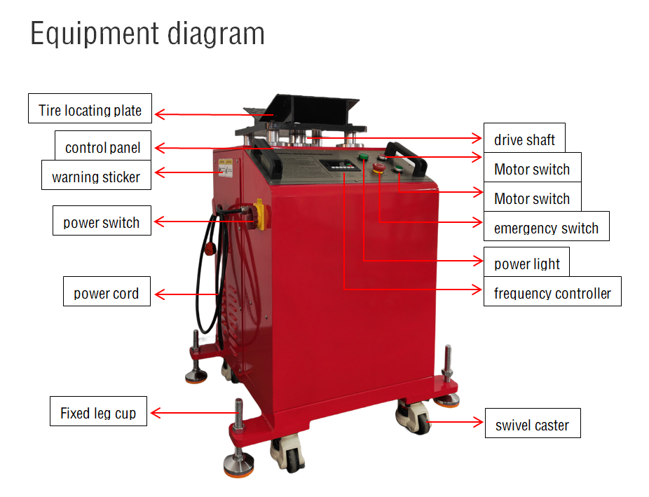
Ⅴ、technical specification
nominal voltage | 220V380V/50-60Hz | motor power | 2.2KW（frequency conversion）
Frequency Range | 0-50Hz | Lifting height | 20MM
Motion frequency | 200 next / minute | load capacity | 3T
Road simulation test host (Steel structure) |  | specification | 730*620*1035mm
Rear wheel safety support (steel structure) |  | specification | 730*500*1035mm
Stress reliever/zero reset bracket |  | specification | 375*170*25MM
machinery wieght |  |  | 600KG
Ⅵ、operation panel
1.power switch | Turn on the switch and the power indicator lights up.
2. Motor switch | 1. Press the motor start switch (green). After the motor starts, the motor running indicator on the panel will light up.  2. Press the motor stop switch (red). After the motor stops, the motor running indicator on the panel will be turned off.
3.frequency converter | Press the run key, the motor works, the knob rotates clockwise to adjust the speed, the counterclockwise to adjust the speed, press the stop key to close the motor.
3.frequency converter | Programming key | Level 1 menu Enter or exit
3.frequency converter | enter key | Enter the menu screen step by step and set parameters to confirm
3.frequency converter | Increasing key | Increment of data or function code
3.frequency converter | Decrement key | Increment of data or function code
3.frequency converter | Shift key | Optionally select the displayed parameters; When modifying the parameter, you can select the modification bit of the parameter
3.frequency converter | Run key | In keyboard mode, it is used to run operations
3.frequency converter | stop key | Used to stop motion operation, subject to H7.04; When the fault alarm, it can be used for fault reset
3.frequency converter | Multifunction | The function is determined by the setting of H7.01, please refer to the function code H7.01 for details
4.emergency stop switch | The button is an emergency button. After pressing the button, the power supply of the control loop is completely removed. The button can be reset by turning clockwise.
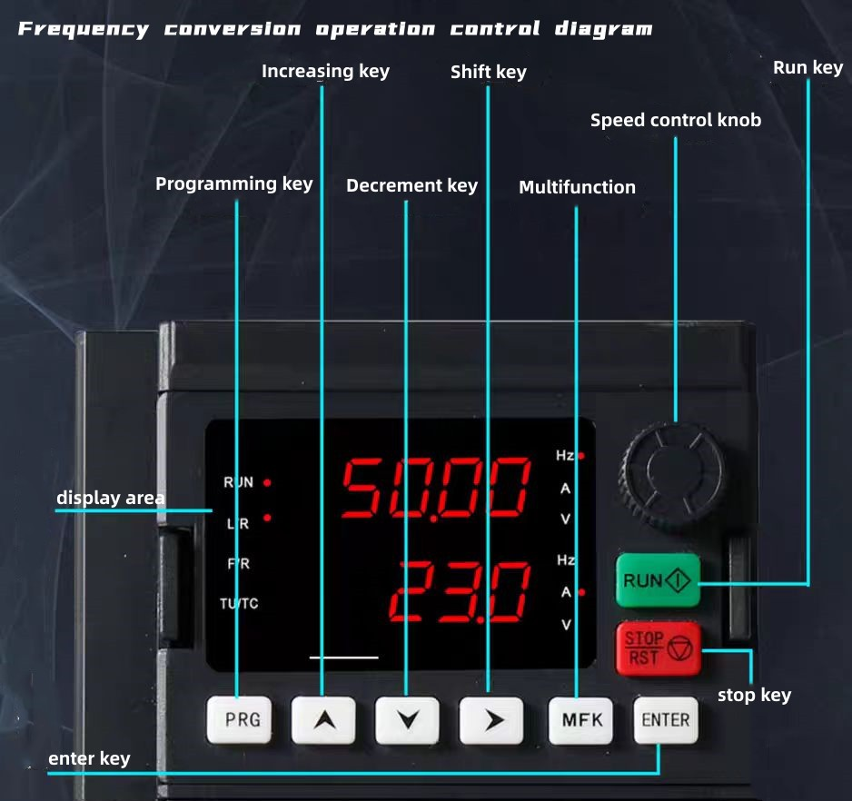
Ⅶ、Operation process
1. Drive the vehicle to the specified construction position, lift the vehicle to a certain height with a double-column lifting platform, move the detection equipment to the front wheel position, move the rear wheel safety fixing bracket to the rear wheel, lift the platform away from the car chassis about 100MM, let the vehicle chassis force equipment V-shaped plate, adjust all the fixed screws of the equipment, let the caster leave the ground about 10MM and lock.
2. In order to ensure that the vehicle fully simulates the road driving condition, release the handbrake and start the detection device to simulate the driving state.
Ⅷ. Operation instructions
1. The power is on, the power switch is turned on, and the power indicator on the console will light up.
2. Press the motor start button, the motor start indicator light will be lit, adjust the movement frequency, (the knob rotates clockwise to adjust the speed, counterclockwise to adjust the speed), the system will automatically move up and down reciprocating, press the motor stop button, the system stops working.
3. Use of the emergency stop button: If an emergency or extraordinary accident occurs in the work, the emergency stop button can be activated (this button cannot be pressed at will, only for abnormal situations). When the emergency stop button is pressed, the power supply of the whole system will be cut off immediately, and then corresponding measures will be taken. After the fault is removed, the emergency stop button on the electric control box can be turned clockwise to reset.
4. After confirming that the motor has stopped working, cut off the power supply. At this time, all lights on the console should be extinguished.
Ⅸ. Personnel training
1. Operators must be trained and certified to start and maintain.
2. Training objects: staff designated by customers, familiar with basic electrical knowledge, good ability to accept understanding, high quality is preferred.
3. Training matters: Technical personnel sent by the equipment manufacturer to teach the operators using the equipment.
4. Training contents include: equipment use, maintenance, maintenance, training.
Ⅹ、Common troubleshooting methods
failure cause | processing scheme
1.Is the power indicator off? | a) Check whether the power cable is connected.
1.Is the power indicator off? | b) Check whether the main power switch is turned on.
2. Press the emergency switch button, but the indicator is not on工作？ | a) Check whether the power cable is connected.
 | b) Whether the main power switch is turned on.
 | c) Check whether the leakage switch is off.
3. Press the motor switch, the motor does not work? | a) Check whether the frequency conversion operation key is pressed and whether the speed control knob is adjusted to the frequency 1-50HZ.
3. Press the motor switch, the motor does not work? | b) Check whether the leakage switch is off.
4.Motor work, detection equipment does not move up and down? | a) Check whether the belt is off and the main shaft screw is off.
4.Motor work, detection equipment does not move up and down? | b) Whether the eccentric bearing of the main shaft falls off.
Note: If you can't handle the above steps, please contact customer service.
Ⅺ、after-sales service
Synge syndrome
product name |  | Type number
date of manufacture
Assembly group |  | inspector
The products shall be allowed to leave factory after passing the inspection

Repair card
product name |  | Type number
seller |  | sales date
username |  | Contact information
User notice
1. After purchasing the product, the user must send the product warranty card receipt and a copy of the invoice to the company within one month to contact each other for maintenance business.
2, the user from the date of purchase, with this card warranty for one year.
3, the use of equipment must refer to the use of the manual in detail, during the warranty period is indeed the manufacturer's quality fault free repair or replacement parts.
4, due to transport damage, improper operation or self-disassembly, not within the warranty!

Warranty repair receipt
product name |  | Type number
seller |  | sales date
username |  | contact information
site
Note: Please fill in the receipt in detail, the receipt is invalid without the seller's stamp and the copy of the invoice!

